Teams: CNCF, CNCF

What is Multicloud, and what is advantage of it? Multi-cloud is when an individual or organization uses more than one cloud provider for their IT needs. This approach enables companies to better support their business, technology, and service reliability requirements, while mitigating over reliance on a single-cloud provider that might not accomplish all tasks effectively.

Different cloud providers? AWS, AZURE, GCP, ALIBABA Cloud…

Different platform to deliver solution:

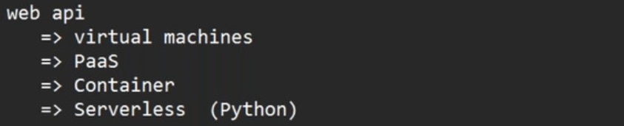

Area where AI is not good? Design and troubleshooting